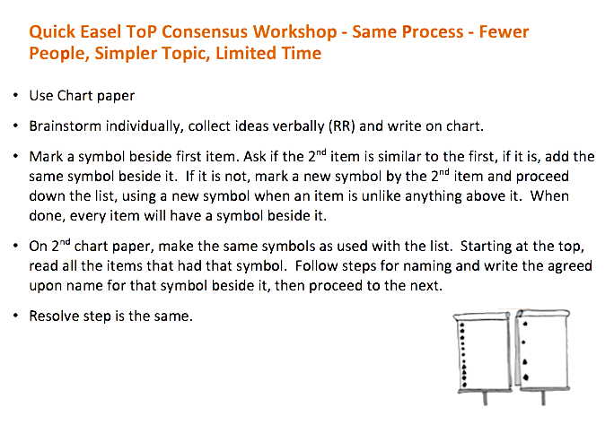

California SNAP-Ed ToP Facilitation Virtual Mentoring Project